**ASSIGNMENT 1**

|  |  |
| --- | --- |
| **DATE** | 13th September 2022 |
| **ROLL NUMBER** | 2019503015 |
| **NAME** | GUHAN B |
| **TEAM ID** | PNT2022TMID35662 |

1. **Write a code in an IDE and run the code through command prompt. Write a code in Spyder and run the code.**

**SOURCE CODE**

n = int(input())

for i in range(n):

    for j in range(i):

        print(i, end=" ")

    print(end="\n")

**OUTPUT**

Spyder Output

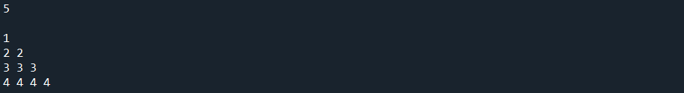

Terminal Output

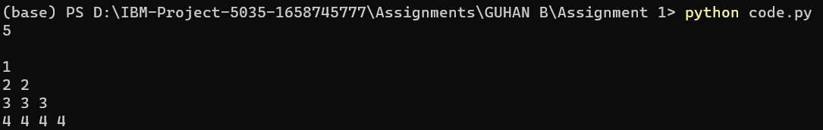

1. **Write a python program to test a given number is prime or not.**

**SOURCE CODE**

import math

def isPrime(n):

    if n <= 1:

        return False

    for i in range(2, int(math.sqrt(n) + 1)):

        if n % i == 0:

            return False

    return True

while(True):

    n = int(input("Enter a number (Enter -1 to exit): "))

    if n < 0:

        break

    if isPrime(n):

        print("PRIME")

    else:

        print("NOT PRIME")

**OUTPUT**

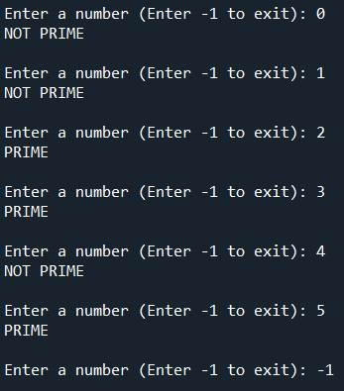

1. **Write a program to generate odd numbers from m to n using while loop.**

**SOURCE CODE**

start = int(input("Enter start: "))

end = int(input("Enter end: "))

print("\nOdd Numbers in given range: ", end=" ")

while start <= end:

    if start % 2 == 1:

        print(start, end=" ")

    start += 1

**OUTPUT**

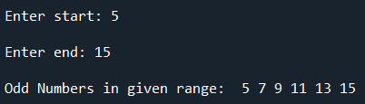

1. **Write a Python program to display prime number series up to given number.**

**SOURCE CODE**

import math

def isPrime(n):

    if n <= 1:

        return False

    for i in range(2, int(math.sqrt(n) + 1)):

        if n % i == 0:

            return False

    return True

while(True):

    n = int(input("Enter N (Enter -1 to exit): "))

    if n <= 0:

        break

    print(f"Prime numbers till {n}: ", end=" ")

    for i in range(n + 1):

        if isPrime(i):

            print(i, end=" ")

    print()

**OUTPUT**

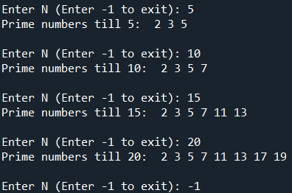

1. **Write a Python program to generate Fibonacci series.**

**SOURCE CODE**

def fibonacci(n):

    a = 0

    b = 1

    print(a, end=" ")

    for x in range(1, n + 1):

        print(b, end=" ")

        next = a + b

        a = b

        b = next

while True:

    n = int(input("Enter N (Enter -1 to exit): "))

    if n < 0:

        break

    print(f"{n} fibonacci numbers are:", end=" ")

    fibonacci(n)

    print()

**OUTPUT**

